EXCEL FORMULA Continuation

1. XLOOKUP- Searches a range or an array for a match and returns the corresponding item from a second range or array. By default, an exact match is used



Basic application of xlookup. You select the value that you want to look up then choose the range where you want to look up then what will be returned if the value is found. In this example the email will be returned if “Toby Flenc..” is found in the “FullName” column

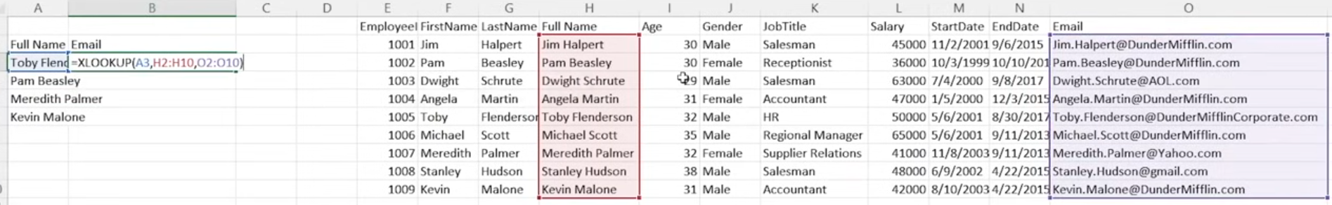

2. XLOOKUP MULTIPLE ROWS – cons: it can ONLY RETURNS CONSECUTIVE ROWS/COLUMNS

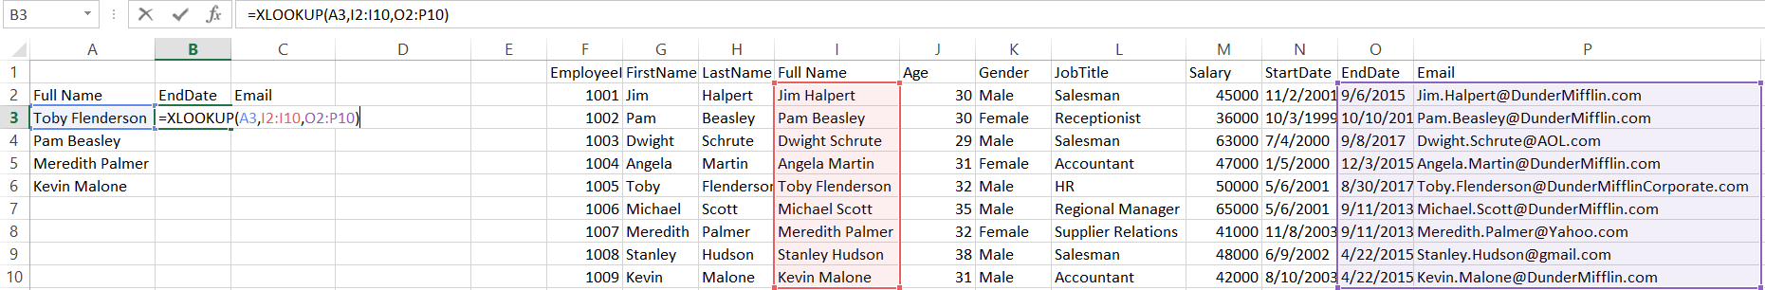

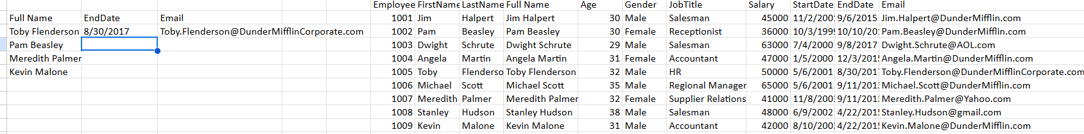

3. XLOOKUP Exact Match – puts a return statement if match not found

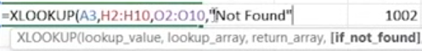

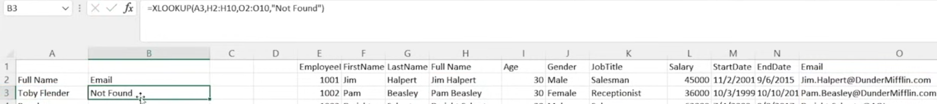

4. XLOOKUP Wildcard character match (Match Mode 2) – partial matching

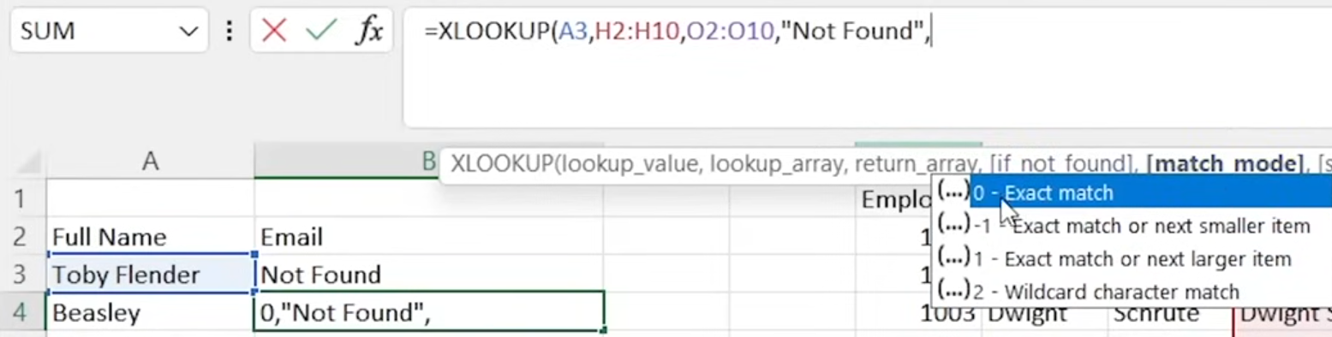

The wildcard expression "*" & something is a way to **build a partial match string** in Excel, often used when combining text dynamically.

**What it means:**

* * is a wildcard that matches **any number of characters**.
* & is the **concatenation operator** in Excel — it joins text together.

So "*" & A1 means:

"*Match any text* ***ending with*** *the value in cell A4"*



So for this example only “Beasley” has an output for there is a value ENDING WITH “Beasley” in column “FullName” while there is no data/value ENDING WITH “Meredith”

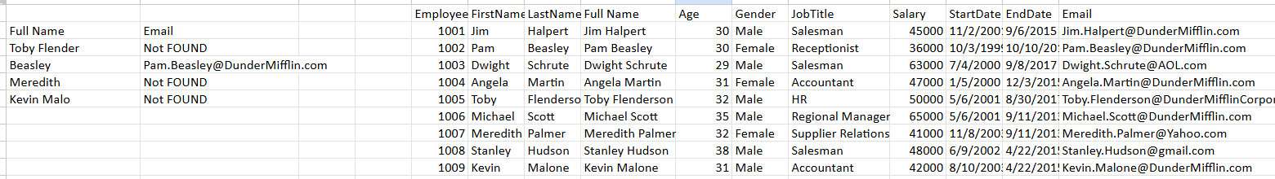

When changing the position of wild card like this *A6 &"*"* means STARTING WITH

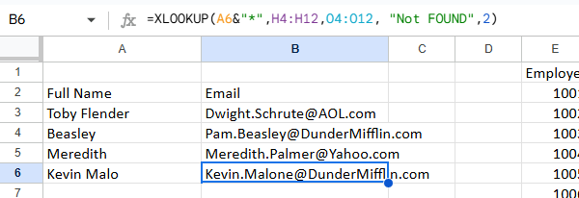

While still on ‘Wild card mode”, you can search the starting few letters by using below syntax

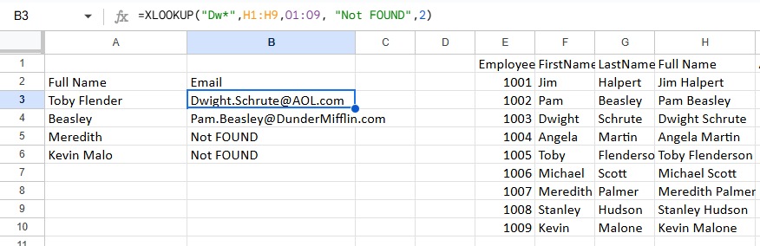

MODE 1- Exact match or Next larger item

The next larger item after A3(1/1/2000) from column N is (1/5/2000) and it will return the value in row I

Note: double comma means it skips the parameter which is ‘[if_not_found]’

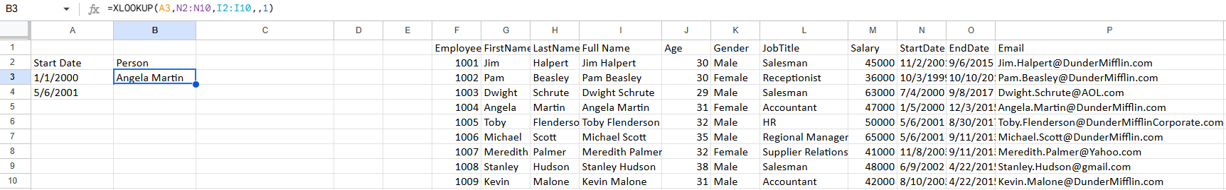

5. XLOOKUP SEARCH ORDER- has 4 mode search

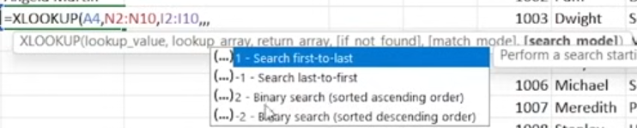

MODE 1 (Search first-to-last) – perform a search starting at the first item. Returns the first similar item from the top of the list

SO you can see here that column ‘I’ is the return value and column ‘N’ is the searching column, there are duplicates in row 6 &7. Using the search order mode 1 it will return row 6 value (the first encounter)

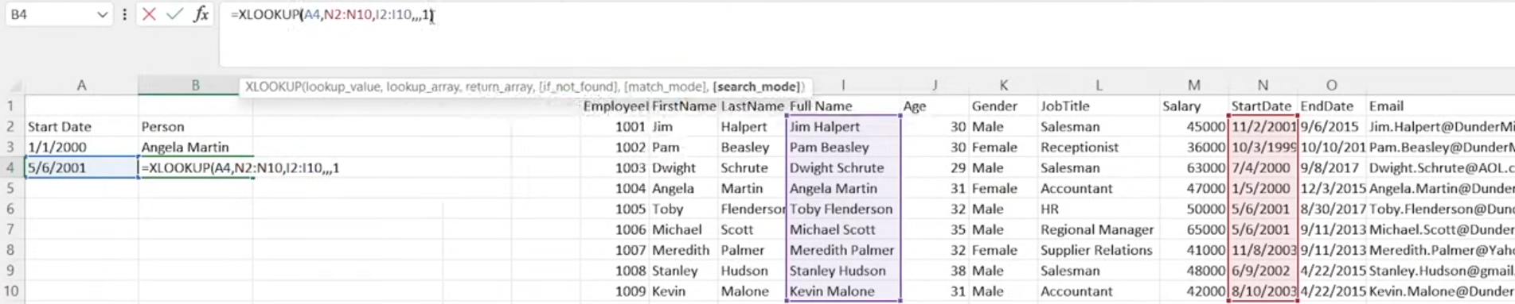

6. XLOOKUP HORIZONTAL – in this look up you are SEARCHING A COLUMN instead of a value. If the column is found the value of the corresponding row will be returned

Here we are searching for column “I1(February)” from rows H1:S1. If found it will return value from H2:S2

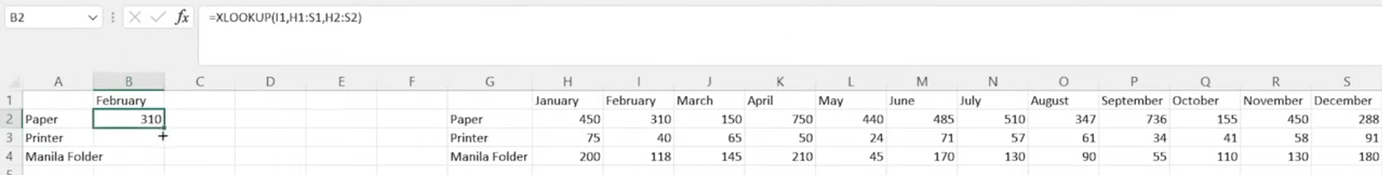

7. XLOOKUP WITH SUM- the first and second value are BOTH XLOOKUP

As you can see below the first value to search is I1 then the second is J1. The search range is from H1-S1 and return range is H2:S2. First 1st Xlookup return is 310, 2nd is 150. Therefore =SUM(310,150) is 460

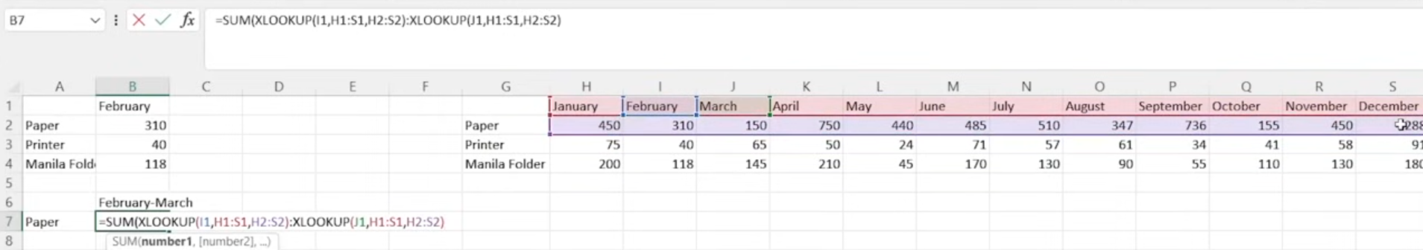

8. VLOOKUP

The ‘table_array’ is a RANGE OF COLUMNS( NOT 1 column) to search for the lookup_value.

col_index_num is the index number of the column where the value is returned. So from the range of table_array of H2:O10, column ‘H’ is index 1, ‘I’ is index 2 and the last column ‘O’ is index 8.



range_lookup- for EXACT MATCH the values can be NOT in any order



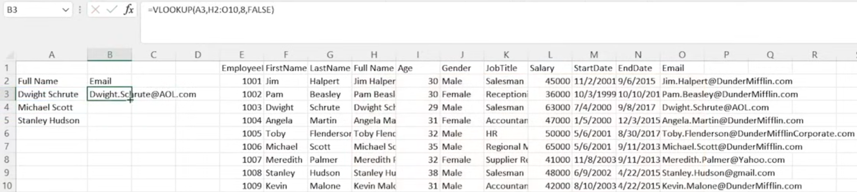

CONS of VLOOKUP – because it is returning value based on index, if there are added columns, the result will change

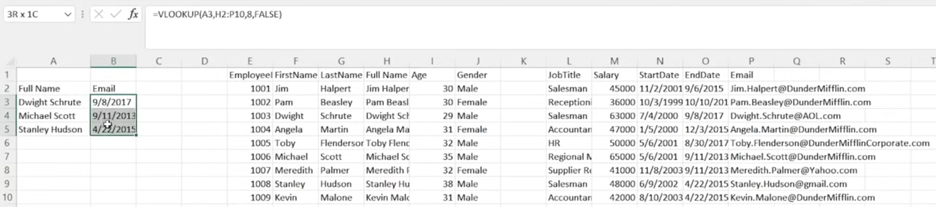

In XLOOKUP- the column automatically adjust Column ‘J’(Address) is added. The return range O:2-O:10 automatically changes to P2:P10, indicating that we want a return value from email no matter how many columns we added

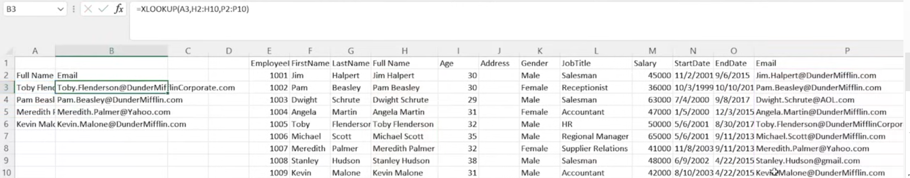

CONDITIONAL FORMATING

**Conditional formatting** in Excel lets you automatically change the appearance of cells (like color, font, borders) based on their values. It's a great way to highlight trends, outliers, deadlines, duplicates, etc. in data

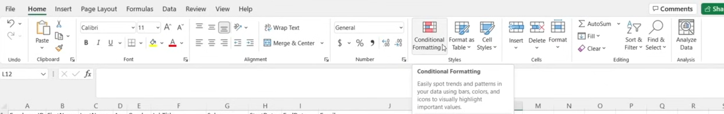

To use the format just select row and choose the format

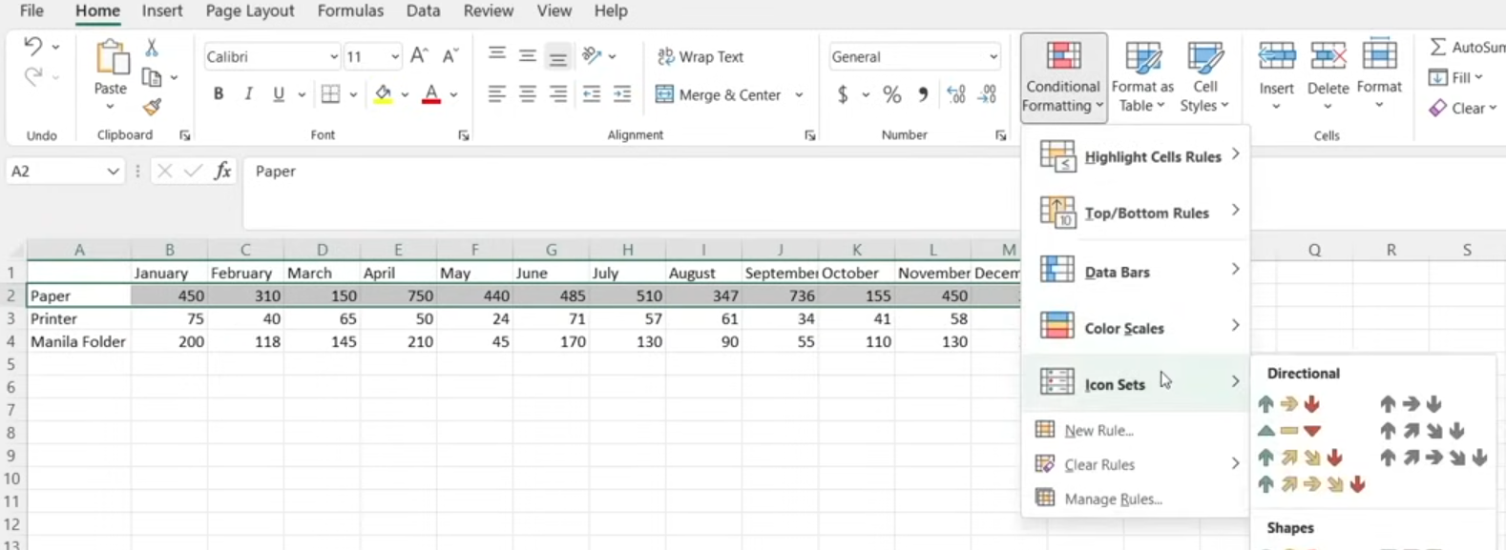



If you select all rows it will compare all data to the first row of data, so the remaining data will always be red. Comparing should be BY ROWS



Color scales- the same with arrow. It color cells based on ascending order

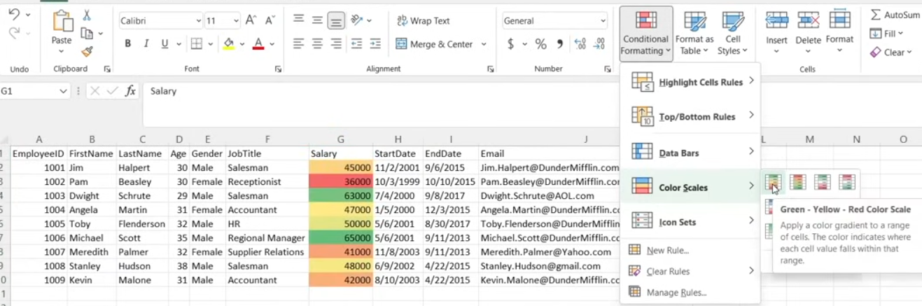



CLEAR RULES- erases all formatting

Top/Bottom Rules – highlight only certain data that met the condition.

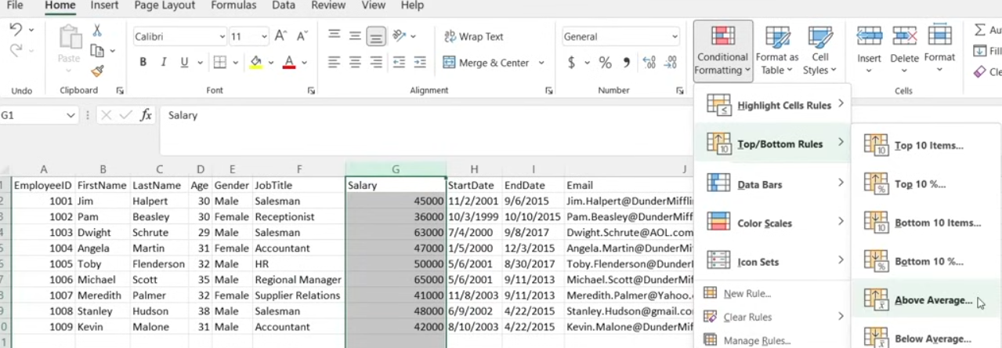

Example: Above average highlights all salary above average. SO it automatically computes the average

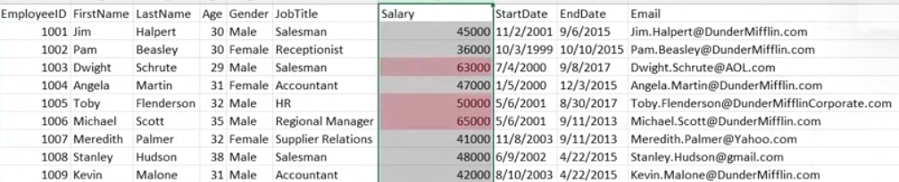

Duplicate values is the most useful

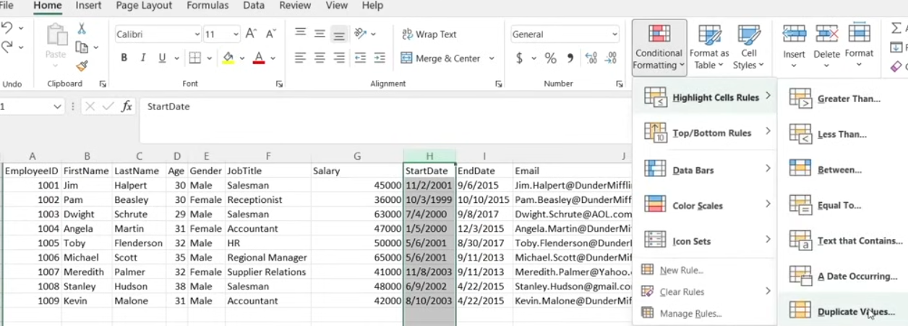

Sorting by color: Select the column ->DATA -> FILTER-> click the dropdown box -> Sort by Color

After you highlight what you are looking for then you can sort it by color. It will be easy life for you if you want to find something in a big data set

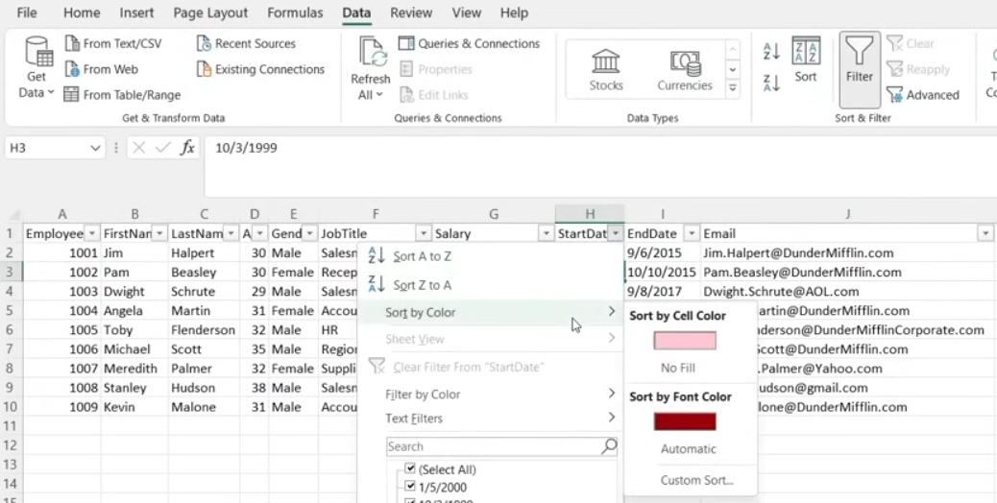

Text that contains – very useful to look for something then combine it with sorting by color

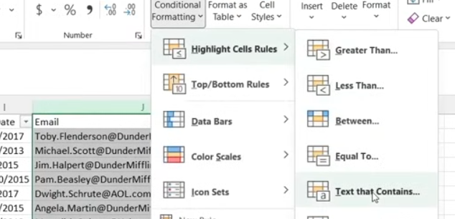 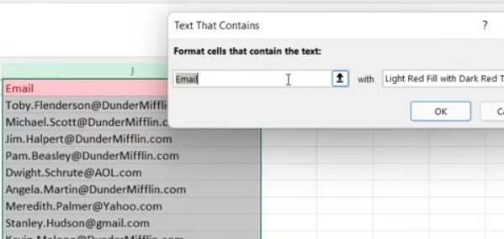

Finding email that is using ‘gmail’ and using red color to highlight it

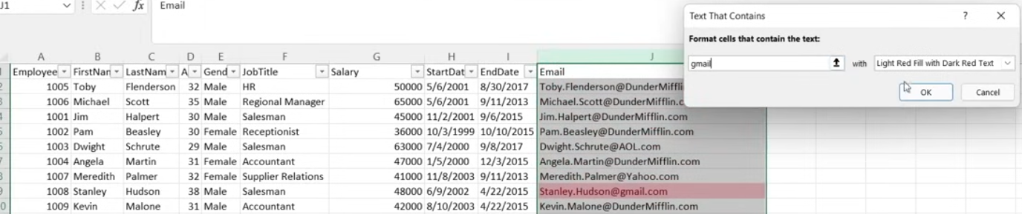

Or some email that has particular text on it and then you can use sorting

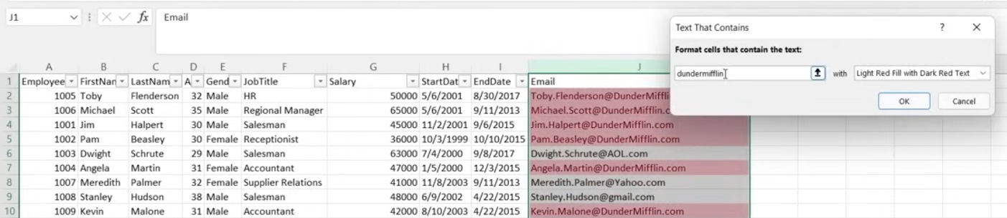 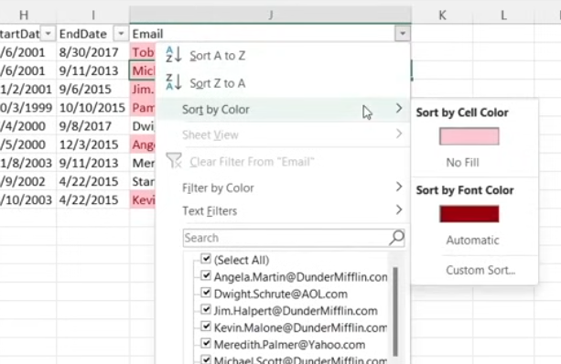

You can also search for symbols

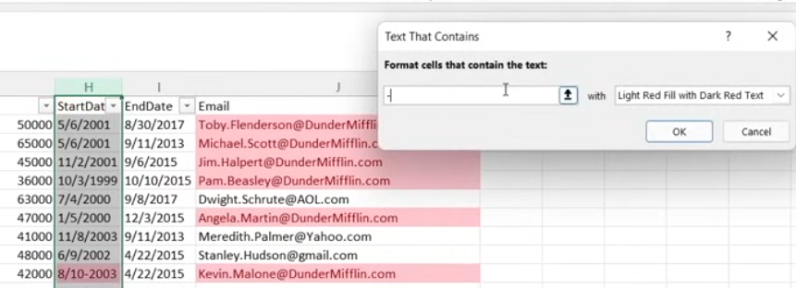

MAKING RULES (Home -> Conditional formatting -> New Rule -> Use a formula…)

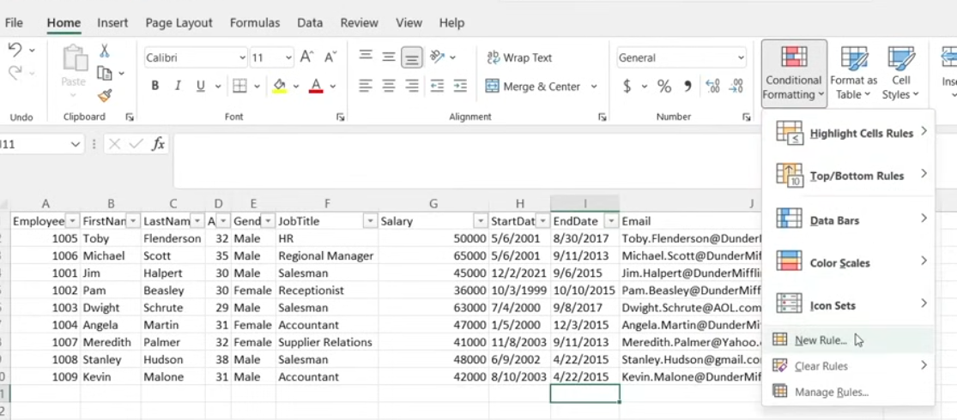

In the “Format values where…” box, you can put any formula

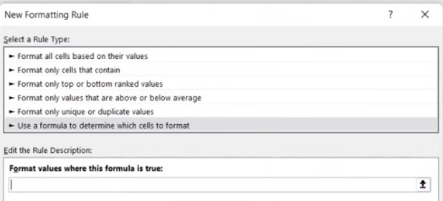

In making rules you should select the cell range then use a conditional/logical statement. REMOVE THE $ sign

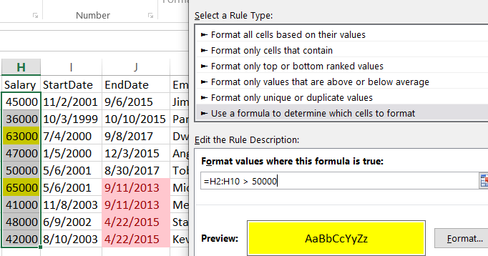

Why remove the $ sign? $ means harcoded values only and formula will not apply to any cell. Put equal sign first then select the table range. It will automatically print the range with the $ sign. You can opt to change the cell color by using the format. Use a conditional statement or any formula. If only the range is in the box and you press ‘OK’, it will have error, The box needs a condition

Then go to “Manage Rules” (Conditional formating -> Manage Rules)

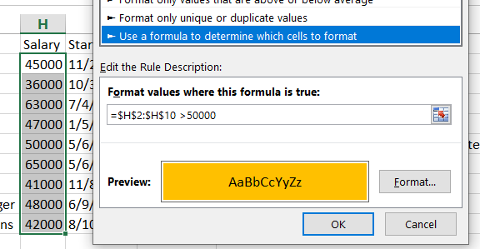 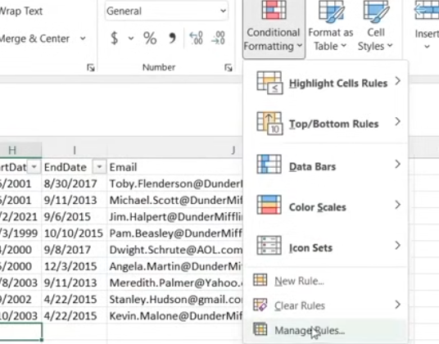

You can see here that the rule was not applied to the selected column. No cells are highlighted even though there are values above 50,000. This is because of the $ sign. The formula will only be HARDCODED and will not be applied on the selected range

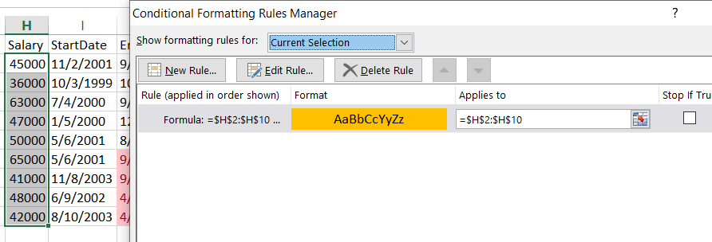

Use ‘Edit Rule” and remove the $ sign on the formula box

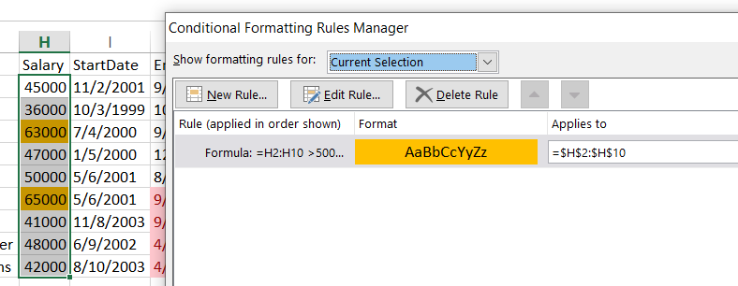

NOTE: If you select a cell while making a rule, even though the formula you inserted is correct, the ‘Applies to’ section will point to the cell selected prior to making the formula

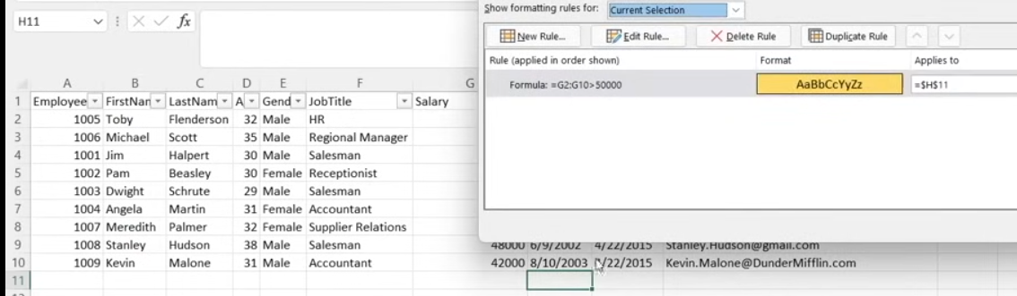

CHARTS

1. Select cell needed to be in the chart -> INSERT -> Charts

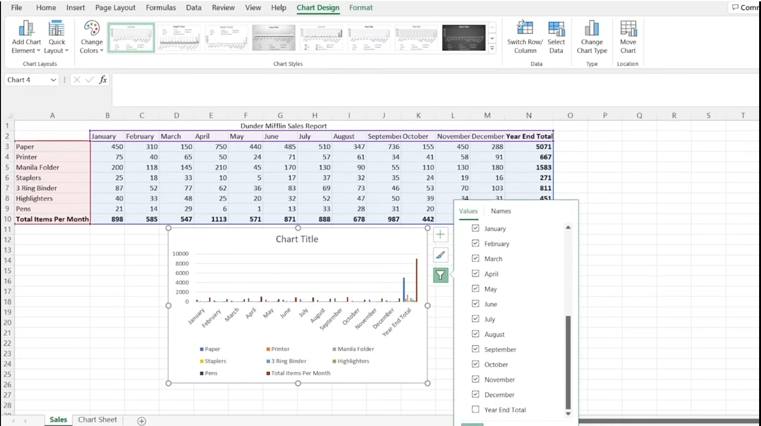

2. After you select a chart , The “ChartDesign” tab will appear. You can “Switch Row/Column” , ‘Move Chart’ , ‘Change chart type’. ‘Select Data’ is similar to the filter button on the photo where you can take a column or rows

CLEANING DATA in EXCEL

1. REMOVING DUPLICATES

Select all -> Data -> Remove Duplicates -> Select All columns (automatic)

NOTE: If you only select one column you might delete rows that does not have duplicate column. “SELECT ALL” make sure that the rows have similarities to ALL columns

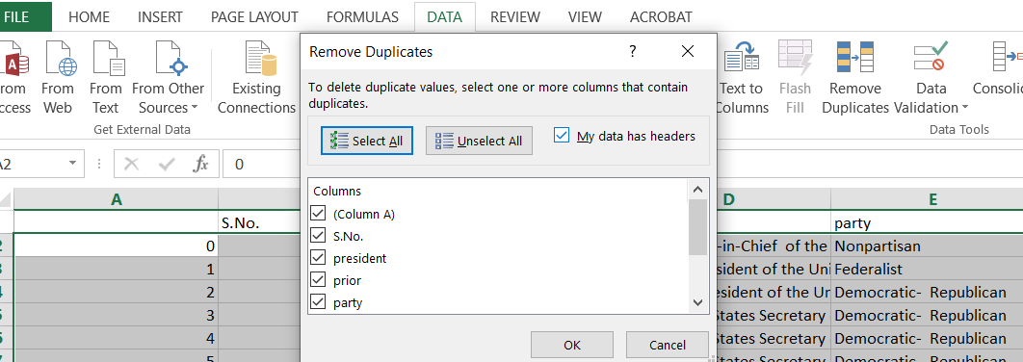

2. PROPER() – Standardized name format

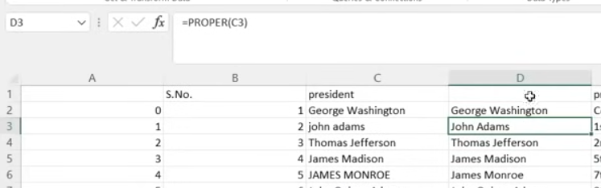

3. So you are in a column, the fastest way to see all the data(Without duplicate) is to look from the filter perspective. To do that Select the first row -> DATA-> filter

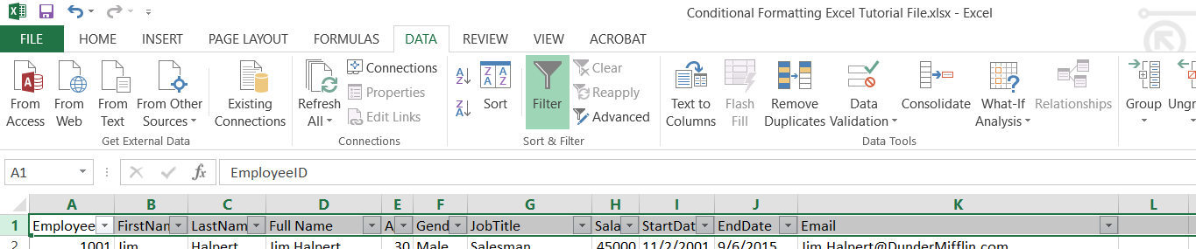

All the checked data are the list of data in that column. This includes seeing if there is a “BLANK”

Use the dropdown arrow. Check the values in each column. You can see in the filter that there are ‘republican’ and ‘republicans’ that looks similar. This might be an example of typo error

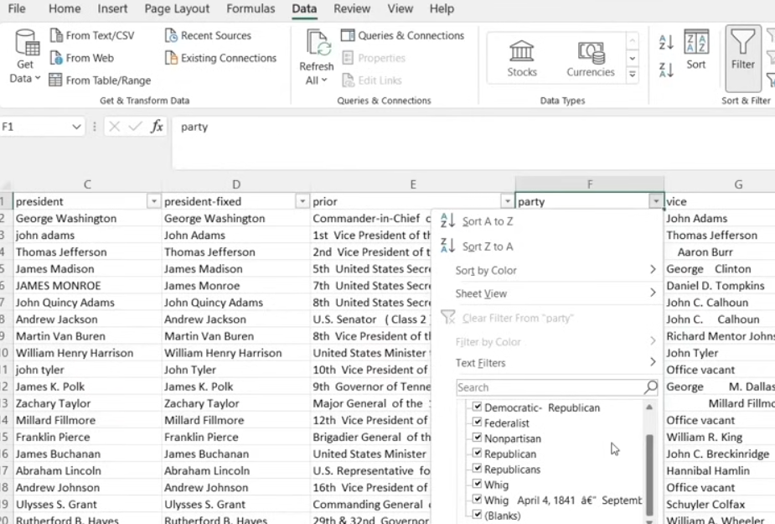

If you look at it, there is one republicans that seems to be mispelled

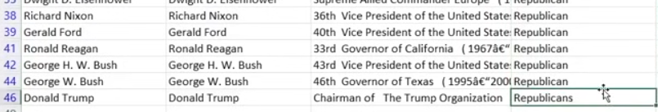

Another one is the “whig”

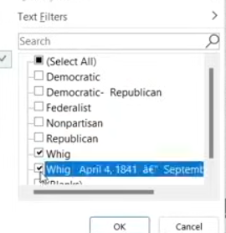 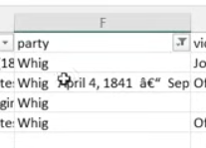

4. TRIM- Removes spaces in-between, front and back. This function only removes extra spaces in the middle. It only retains one space in the middle

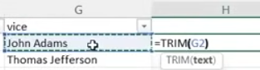 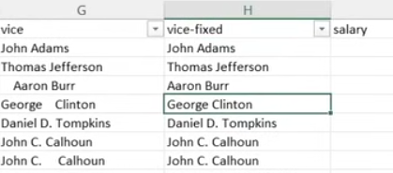

5. Number – when you will insert numeric data in SQL you need it to be in number format while excel. This means no any currency symbol, comma or dot. Remove zeroes by using the 3rd photo below

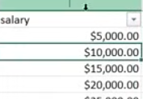 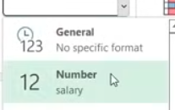 

6. Short Date- sometimes filters on dates appear to be all the same but when you check the actual column, there are different format. Short date can format all rows in column in one date format

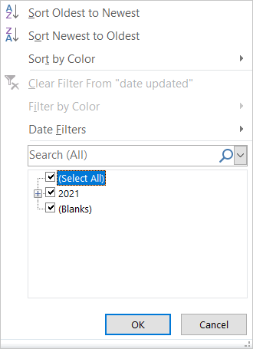 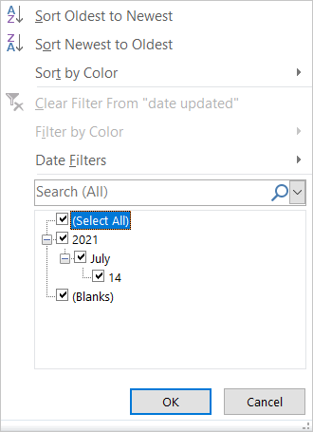 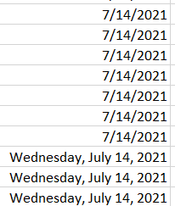 

7. Paste as a Value- It will copy the column in which you have formula, copy ‘vice’ column the paste it as a value in a renamed column like ‘vice-fixed’. This new column does not contain a formula but only a pure value/text

Ctrl +Shift + down arrow = select all rows in that column

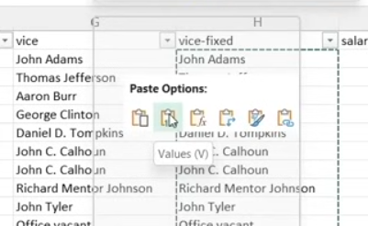

8. DOUBLE CLICK GREEN DOT- if you want to fast apply a formula in all rows of the column, you can double click the green dot on the lower right corner of the cell

